**طراحی سیستم های دیجیتال**

**تکلیف دوم**

**استاد مروستی**

**علیرضا نعمتی**

**کسری رشیدفر**

Table of Contents

Question1 2

JK_FF 2

Code 3

Compilation report 4

RTL 4

Post-Mapping 5

T_FF 6

Code 6

Compilation report 7

Rtl 7

Post-Mapping 8

Question2 8

Code 9

Compilation report 9

RTL 10

Post-Mapping 10

Question3 11

Code 11

Compilation report 12

RTL 13

Post-Mapping 13

Question4 14

Code 14

Compilation report 16

RTL 17

Post-mapping 19

# Question1

## JK_FF

### Code

library ieee;

use ieee.std_logic_1164.all;

entity JK_FF is port(

clk, reset: in std_logic;

j, k: in std_logic;

q: out std_logic

);

end JK_FF;

architecture arch of JK_FF is

signal q_temp: std_logic;

begin

process(clk, reset)

begin

if(reset = '1') then

q_temp <= '0';

elsif (clk'event and clk = '1') then

if(j = '0' and k = '0') then

q_temp <= q_temp;

elsif(j = '0' and k = '1') then

q_temp <= '0';

elsif(j = '1' and k = '0') then

q_temp <= '1';

elsif(j = '1' and k = '1') then

q_temp <= not (q_temp);

end if;

end if;

end process;

q <= q_temp;

end arch;

### Compilation report

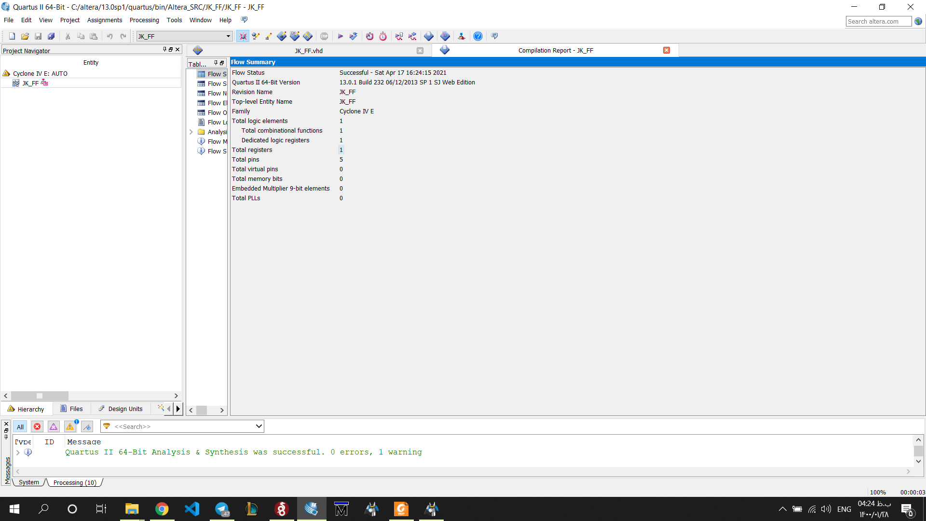

### RTL

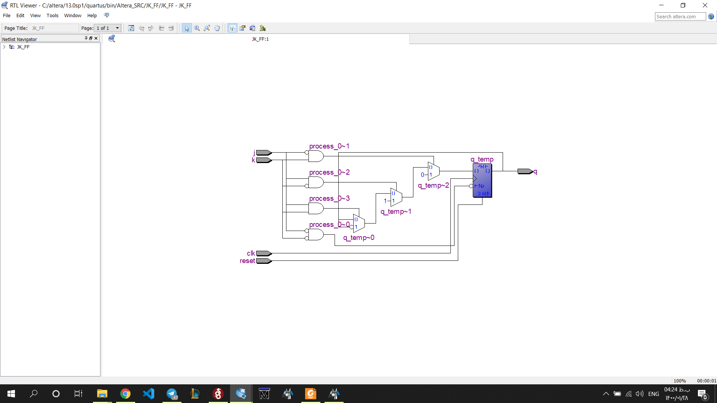

### Post-Mapping

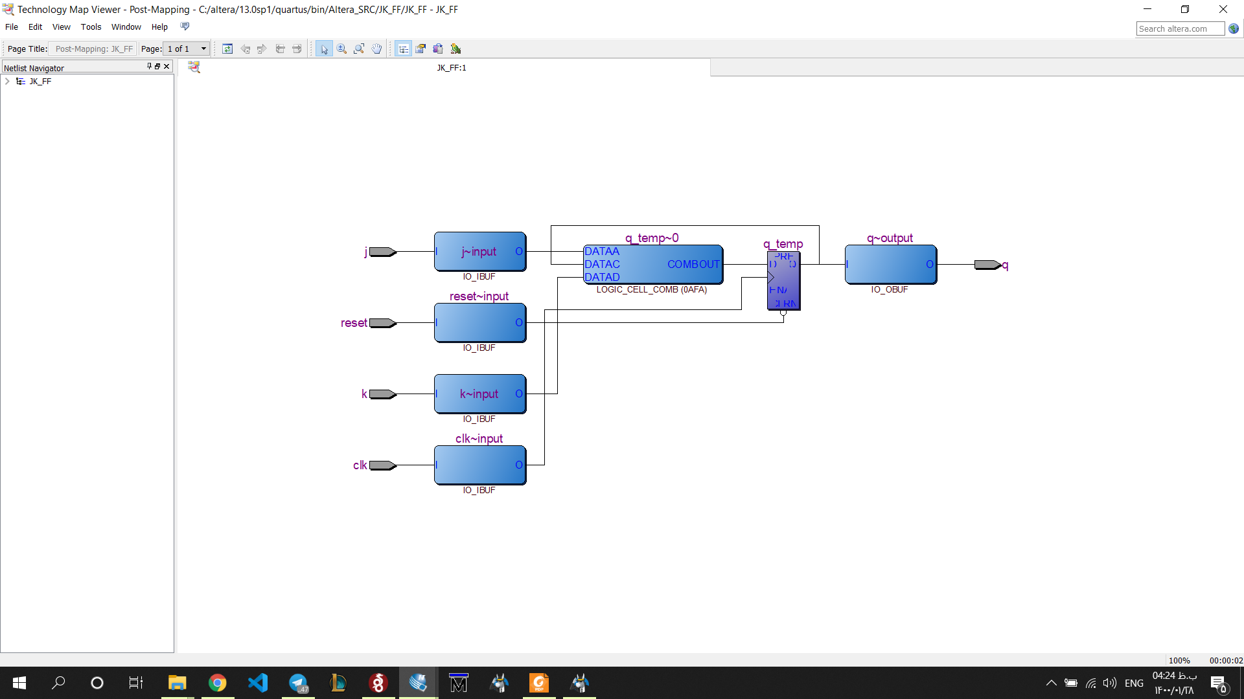

## T_FF

### Code

library ieee;

use ieee.std_logic_1164.all;

entity T_FF is

port(

clk: in std_logic;

reset: in std_logic;

t: in std_logic;

q: out std_logic

);

end T_FF;

architecture arch of T_FF is

signal q_next: std_logic;

begin

process(clk, reset)

begin

if (reset = '1') then

q_next <= '0';

elsif (clk'event and clk = '1') then

q_next <= (t xor q_next);

end if;

q <= q_next;

end process;

end arch;

### Compilation report

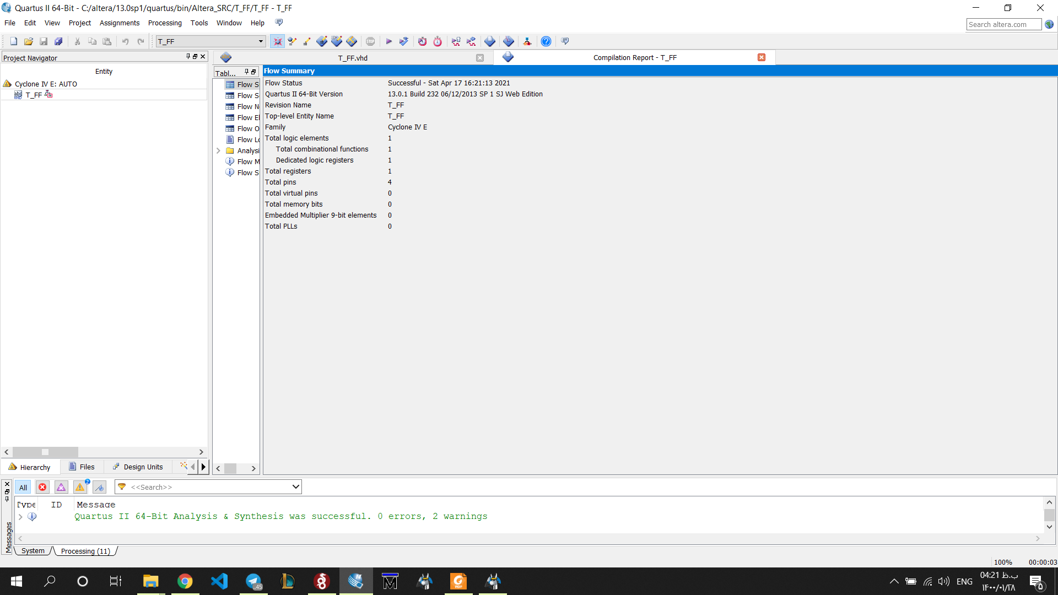

### Rtl

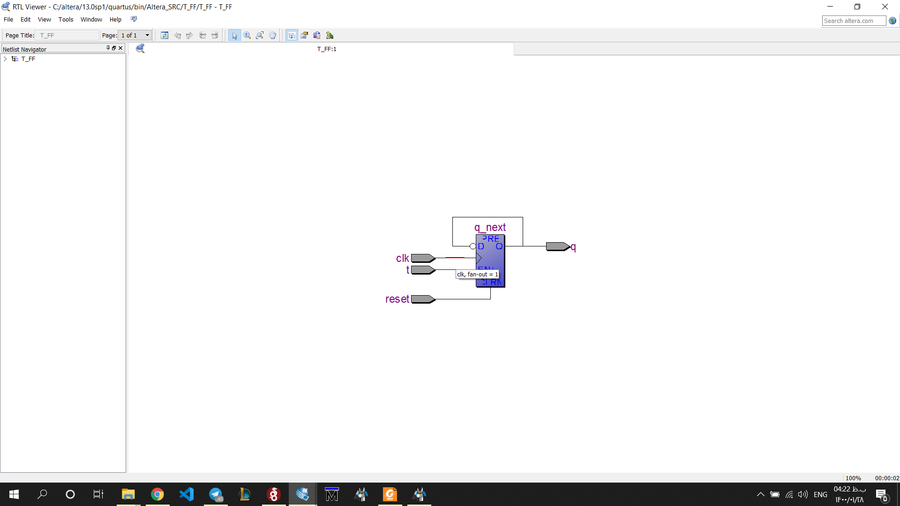

### Post-Mapping

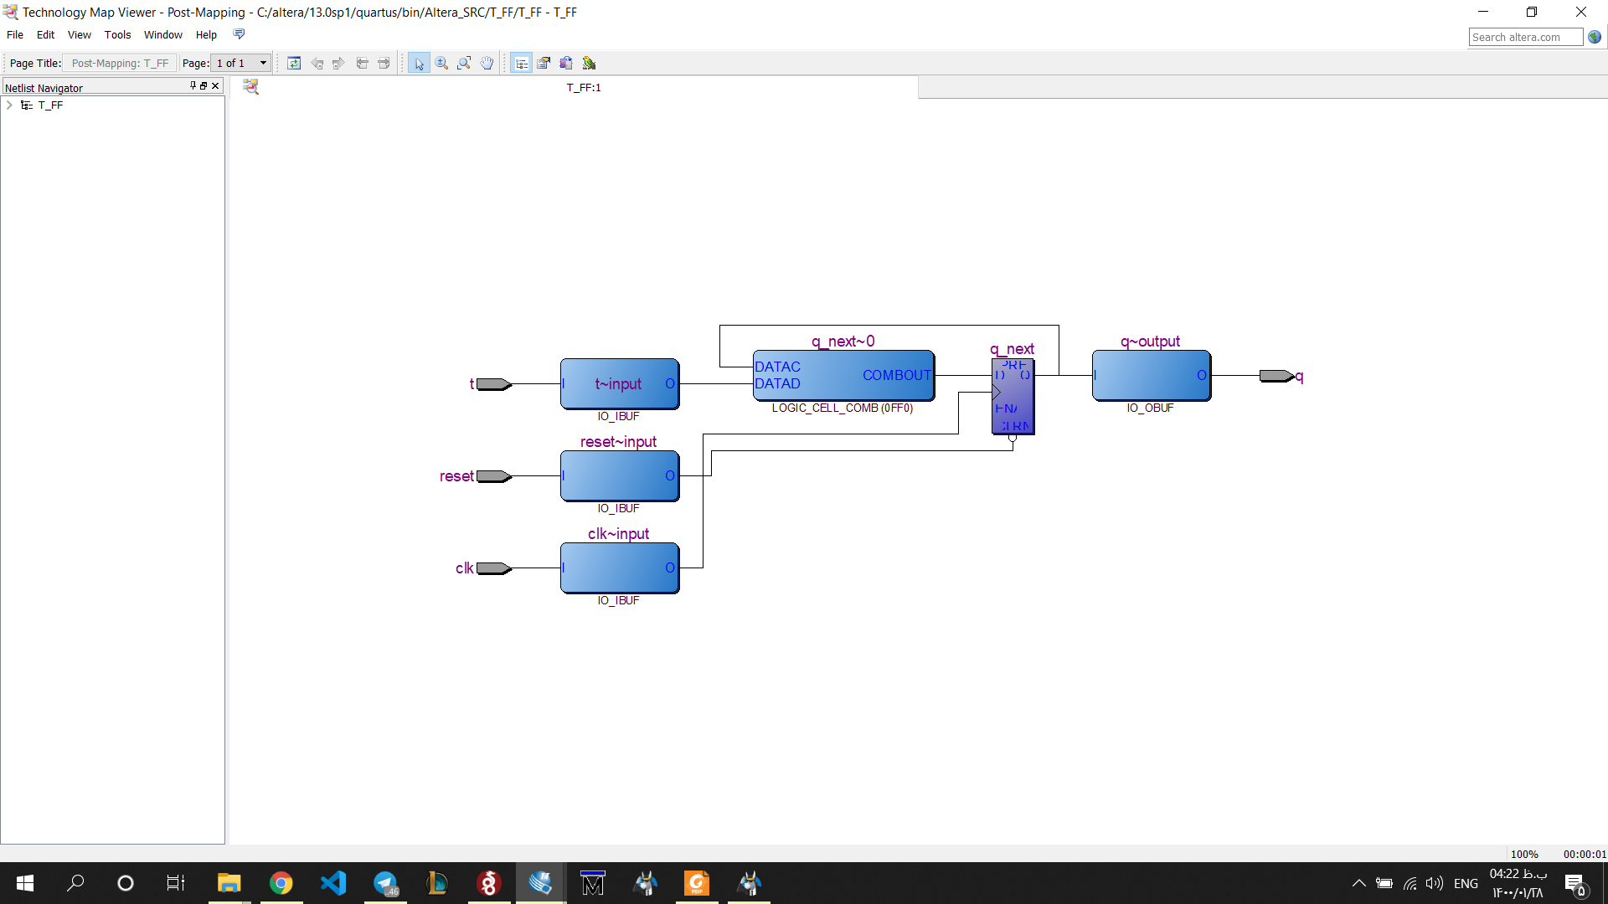

# Question2

## Code

library ieee;

use ieee.std_logic_1164.all;

use ieee.numeric_std.all;

entity BCD_Counter is port(

clk, reset: in std_logic;

Dir: in std_logic;

q: out std_logic_vector(3 downto 0)

);

end BCD_Counter;

architecture arch of BCD_Counter is

signal counter: unsigned(3 downto 0);

begin

process(clk, reset)

begin

if (reset = '1') then

counter <= (others => '0');

elsif (clk'event and clk = '1') then

if (Dir = '1') then

counter <= counter + 1;

elsif (Dir = '0') then

counter <= counter - 1;

end if;

end if;

end process;

q <= std_logic_vector(counter);

end arch;

## Compilation report

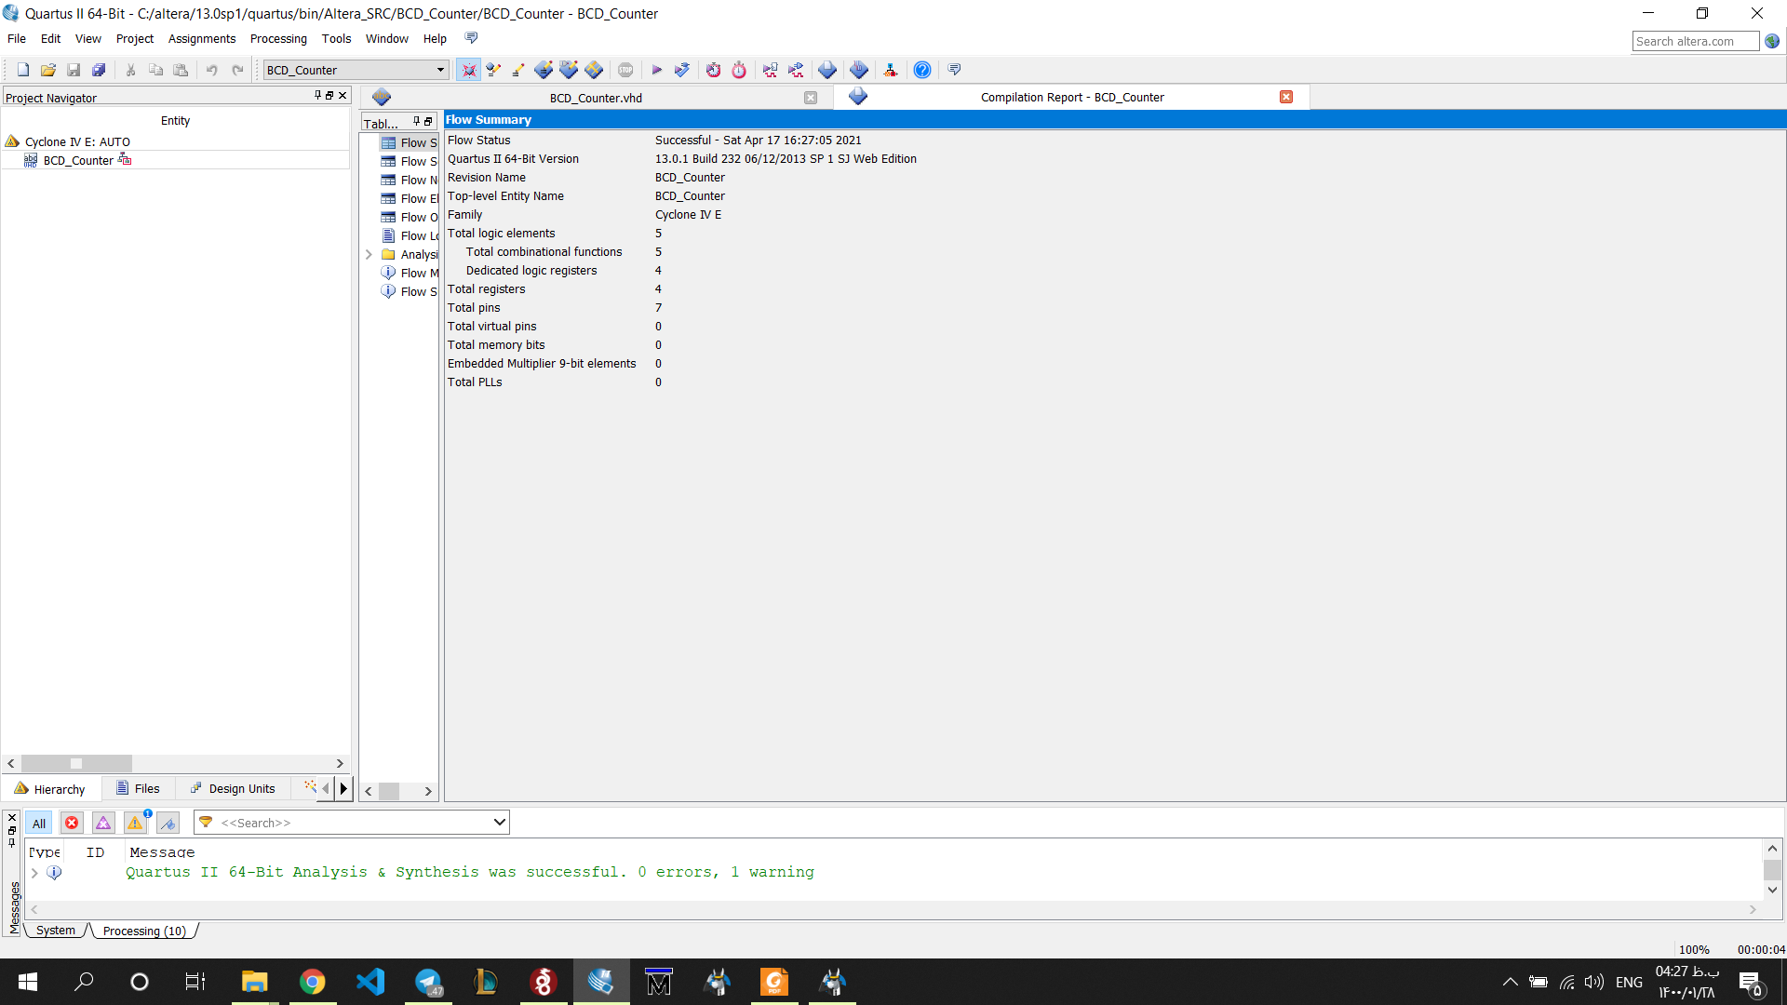

## RTL

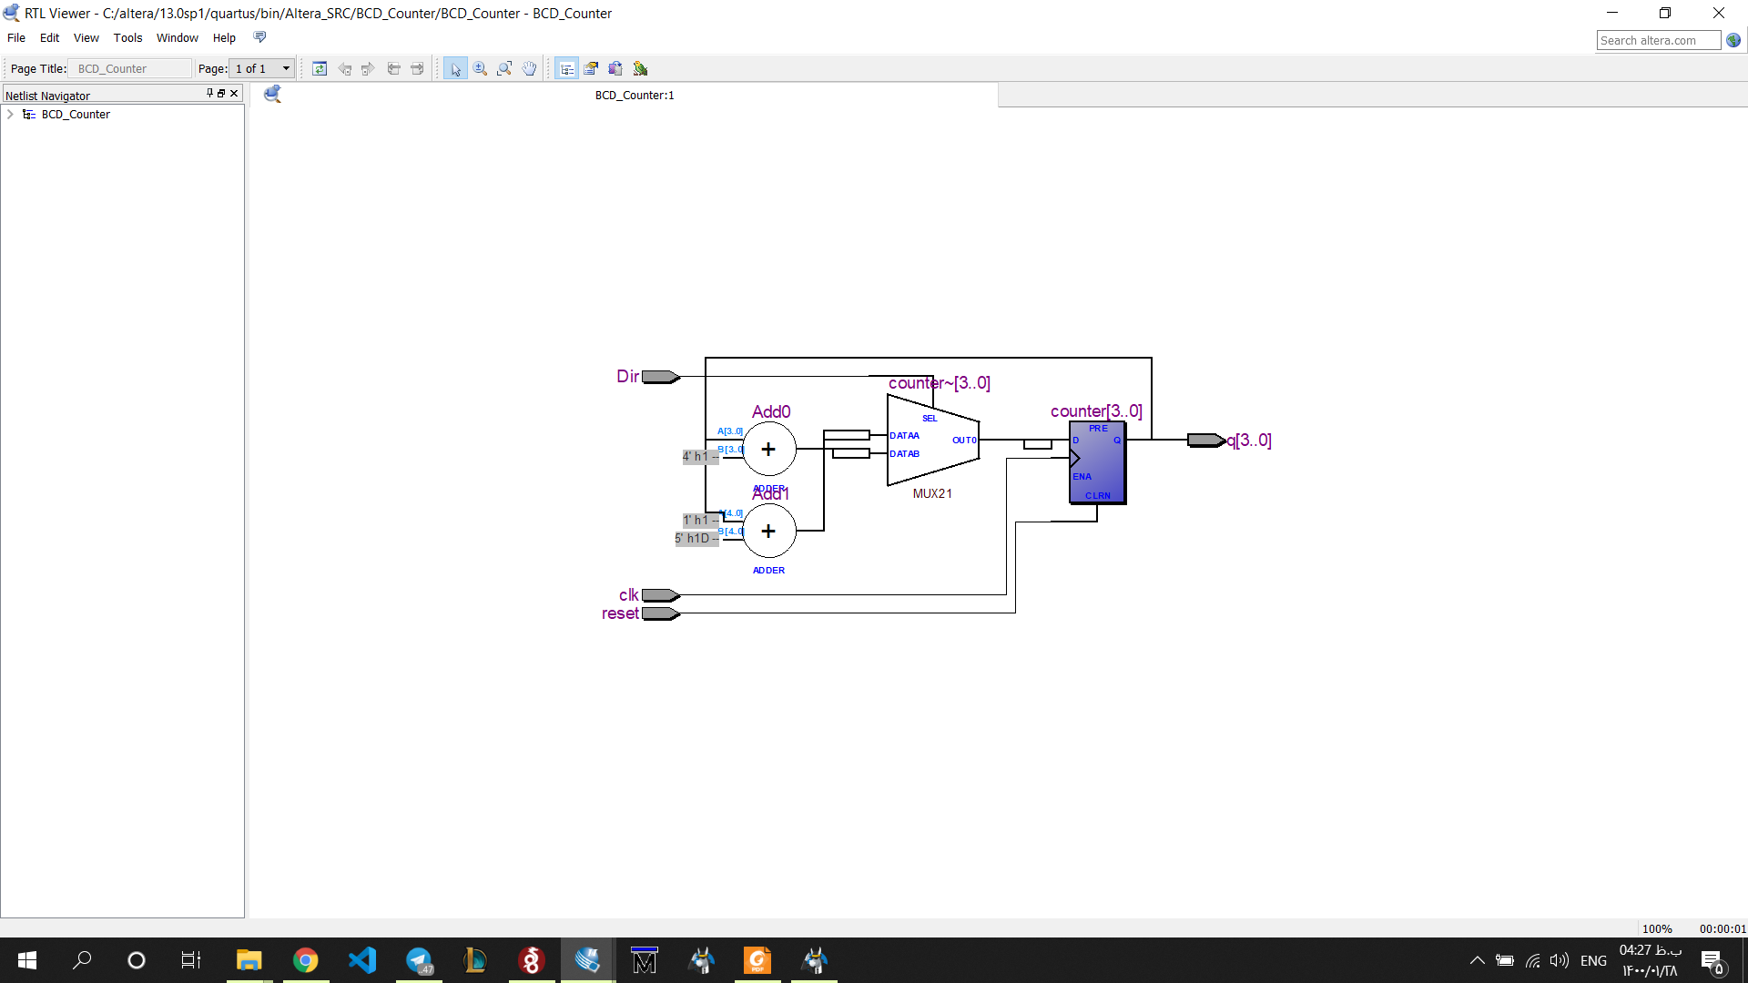

## Post-Mapping

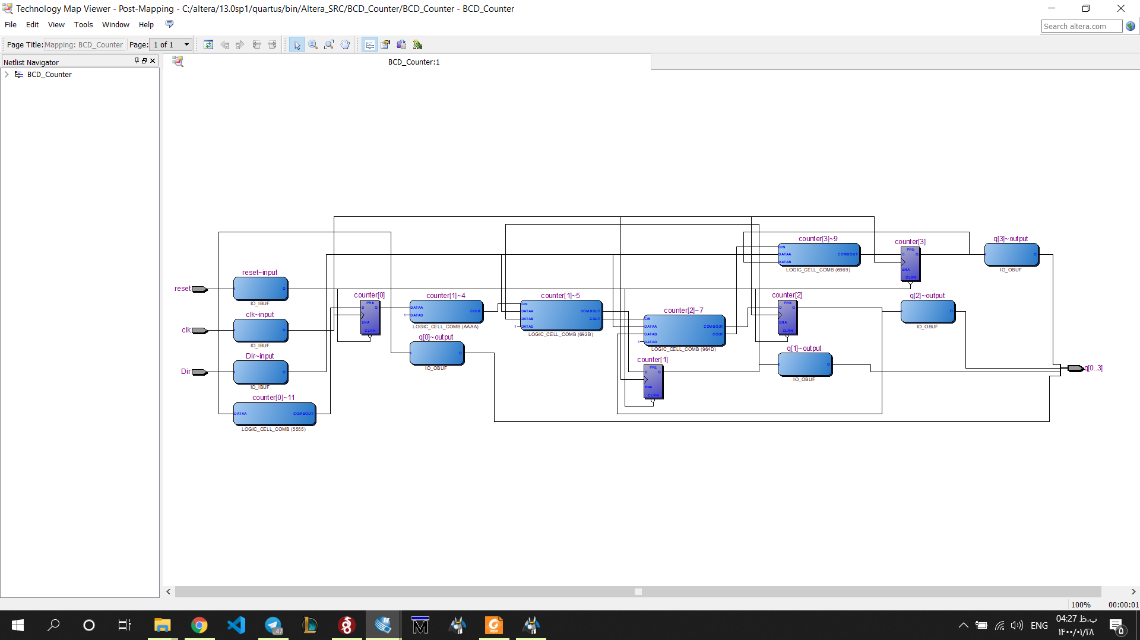

# Question3

## Code

library ieee;

use ieee.std_logic_1164.all;

use ieee.numeric_std.all;

entity arbitrary_counter is

port(

clk, reset: in std_logic;

q: out std_logic_vector(2 downto 0)

);

end arbitrary_counter;

architecture arch of arbitrary_counter is

signal r_reg: std_logic_vector(2 downto 0);

signal r_next: std_logic_vector(2 downto 0);

begin

process(clk, reset)

begin

if (reset = '1') then

r_reg <= (others => '0');

elsif (clk'event and clk = '1') then

r_reg <= r_next;

end if;

end process;

r_next <= "011" when r_reg="000" else

"110" when r_reg="011" else

"101" when r_reg="110" else

"111" when r_reg="101" else

"000";

q <= r_reg;

end arch;

## Compilation report

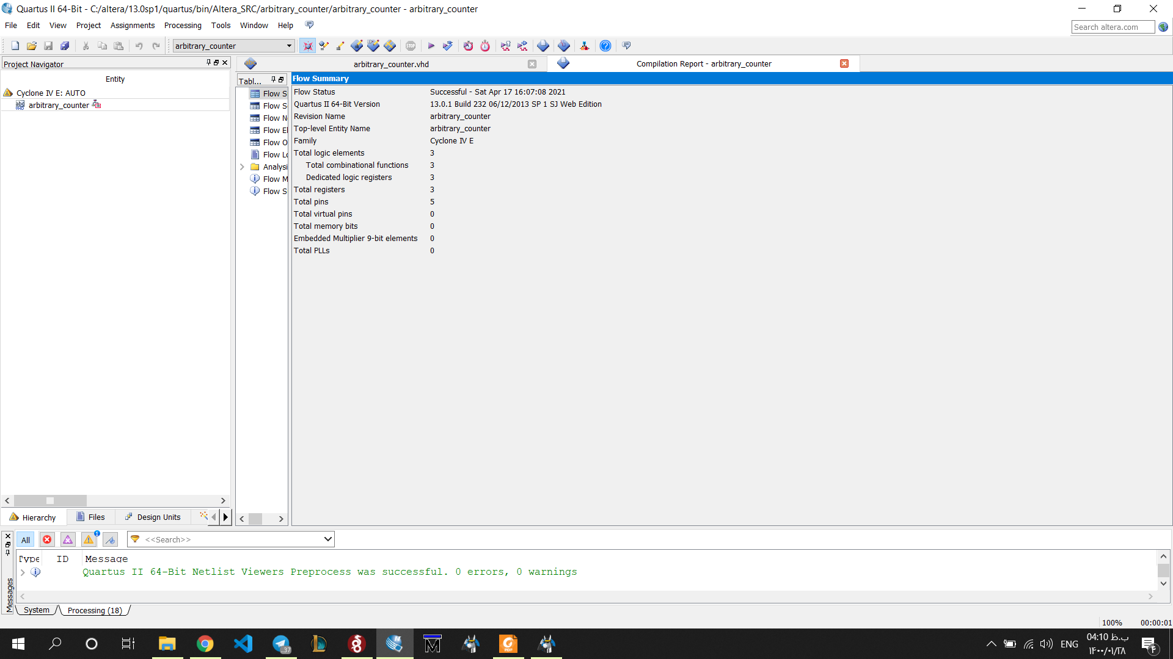

RTL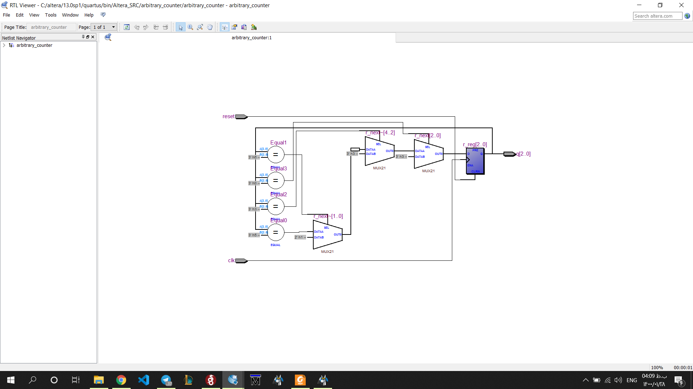

## Post-Mapping

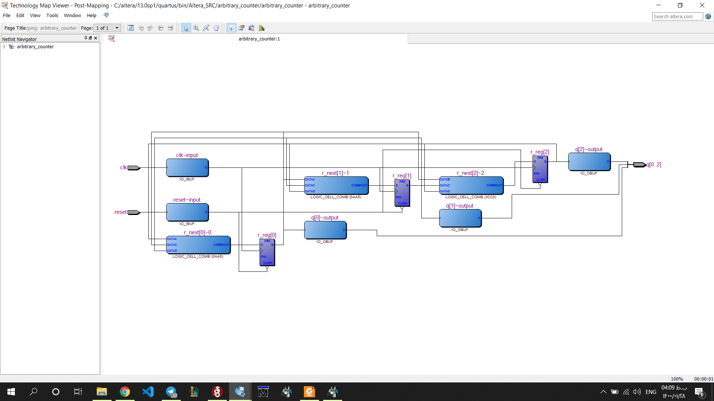

# Question4

## Code

library ieee;

use ieee.std_logic_1164.all;

use ieee.numeric_std.all;

-- use ieee.numeric_std.all;

-- use IEEE.STD_LOGIC_UNSIGNED.all;

entity Fifo_control is

port (

clk, reset : in std_logic;

wr,rd : in std_logic;

full, empty : out std_logic;

w_address,r_address : out std_logic_vector (2 downto 0) );

end Fifo_control;

architecture arch of Fifo_control is

signal reader_pointer : unsigned(3 downto 0) := "0000";

signal writer_pointer : unsigned(3 downto 0) := "0000";

-- signal reader_pointer : std_logic_vector(3 downto 0);

-- signal writer_pointer : std_logic_vector(3 downto 0);

signal full_fifo : std_logic;

signal empty_fifo : std_logic;

begin

process(wr,clk,reset)

begin

if(reset = '1') then

-- reader_pointer <= "0000";

writer_pointer <= "0000";

full_fifo <= '0';

-- empty_fifo <= '0';

elsif(clk'event and clk ='1') then

if(wr = '1')then

if((reader_pointer(2 downto 0) = writer_pointer(2 downto 0)) and (reader_pointer(3) /= writer_pointer(3)))then

full_fifo <= '1';

elsif(writer_pointer = "1111") then

writer_pointer <= "0000";

else

writer_pointer <= writer_pointer + 1;

end if;

if(full_fifo = '1') then

full <= '1';

else

-- i don't know what todod

-- maybe send w_address

w_address <= std_logic_vector(writer_pointer(2 downto 0));

-- w_address <= writer_pointer(2 downto 0);

end if;

end if;

end if;

end process;

process(rd,clk,reset)

begin

if(reset = '1') then

reader_pointer <= "0000";

-- writer_pointer <= "0000";

-- full_fifo <= '0';

empty_fifo <= '0';

elsif(clk'event and clk ='1') then

if(rd = '1') then

if(reader_pointer = writer_pointer) then

empty_fifo <= '1';

elsif(reader_pointer = "1111") then

reader_pointer <= "0000";

else

reader_pointer <= reader_pointer + 1;

end if;

if(empty_fifo = '1') then

empty <= '1';

else

-- i don't know what todod

-- maybe send r_address

r_address <= std_logic_vector(reader_pointer(2 downto 0));

-- r_address <= reader_pointer(2 downto 0);

end if;

end if;

end if;

end process;

end architecture;

## Compilation report

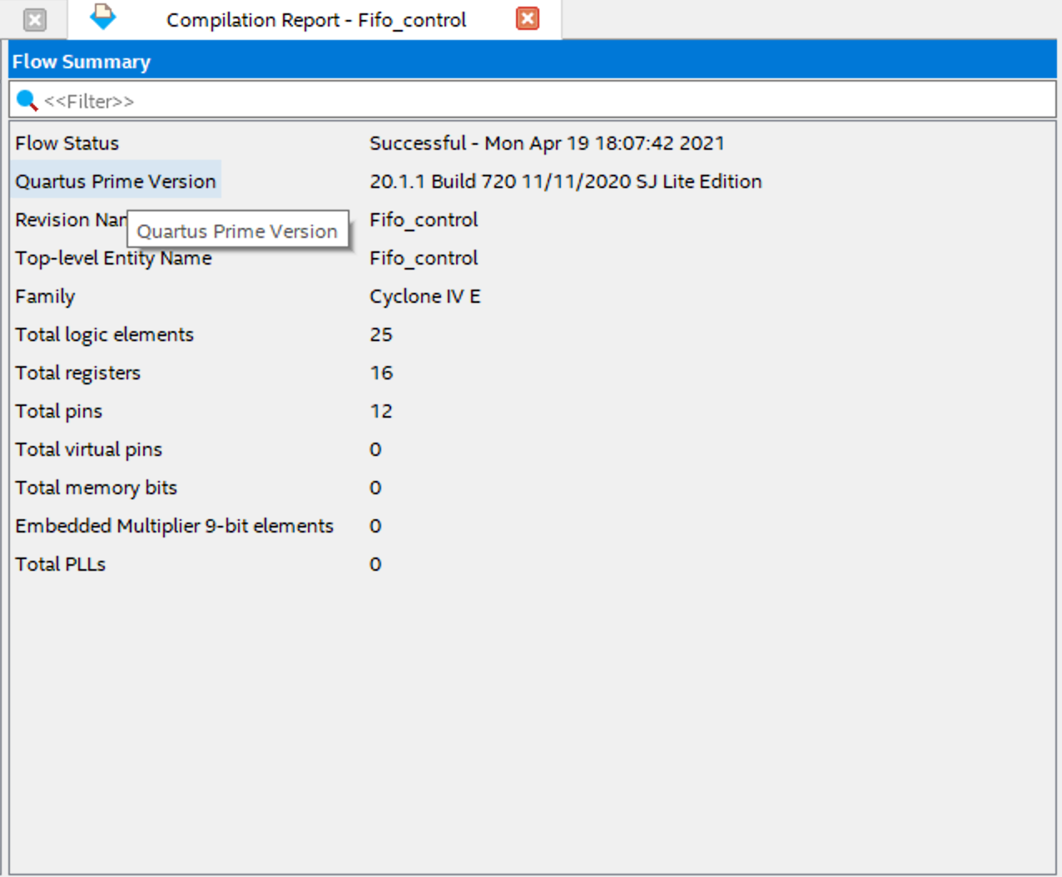

## RTL

**این عکس به دلیل سخت خواندن به۲ قسمت تقسیم شده اند**

**عکس اصلی**

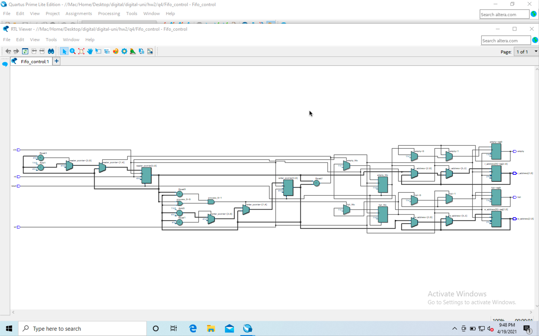

**عکس اول**

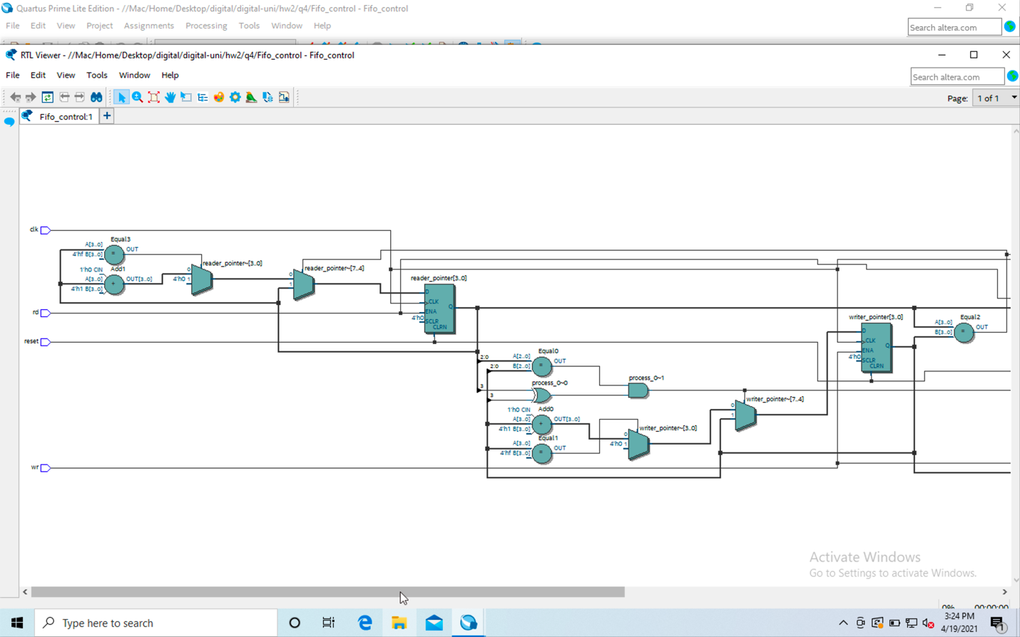

**عکس دوم**

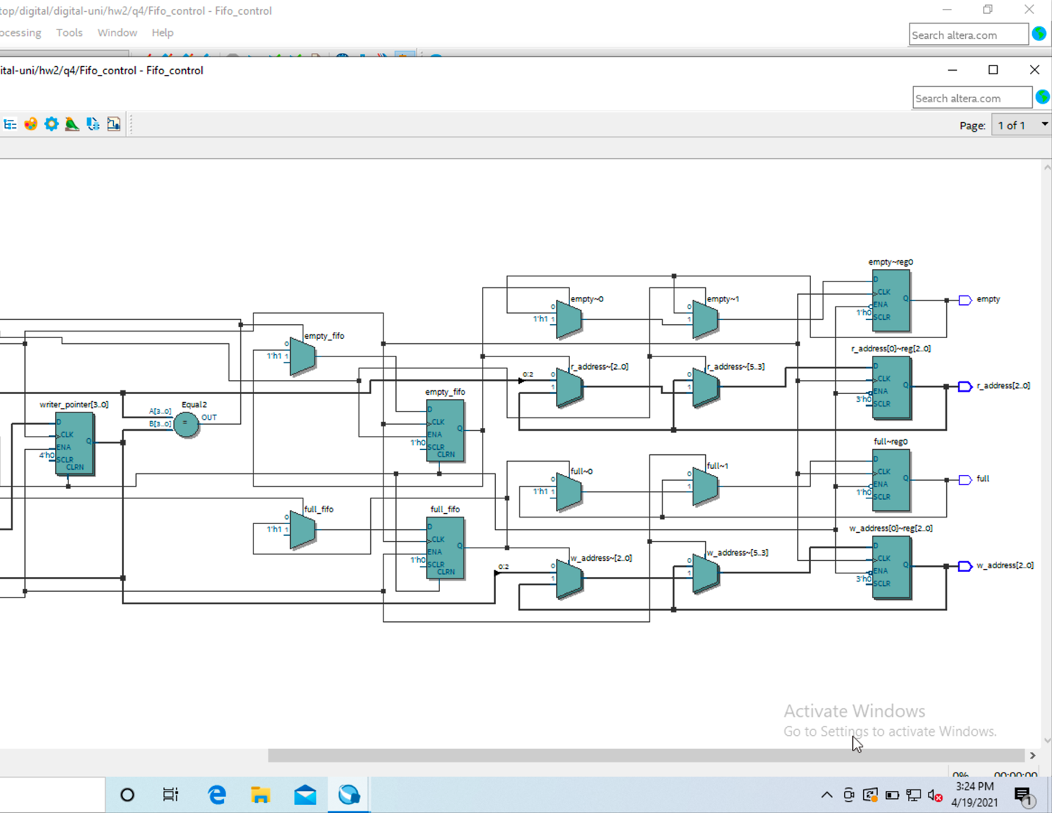

## Post-mapping

**این عکس به دلیل سخت خواندن به ۳ قسمت تقسیم شده اند**

**عکس اصلی**

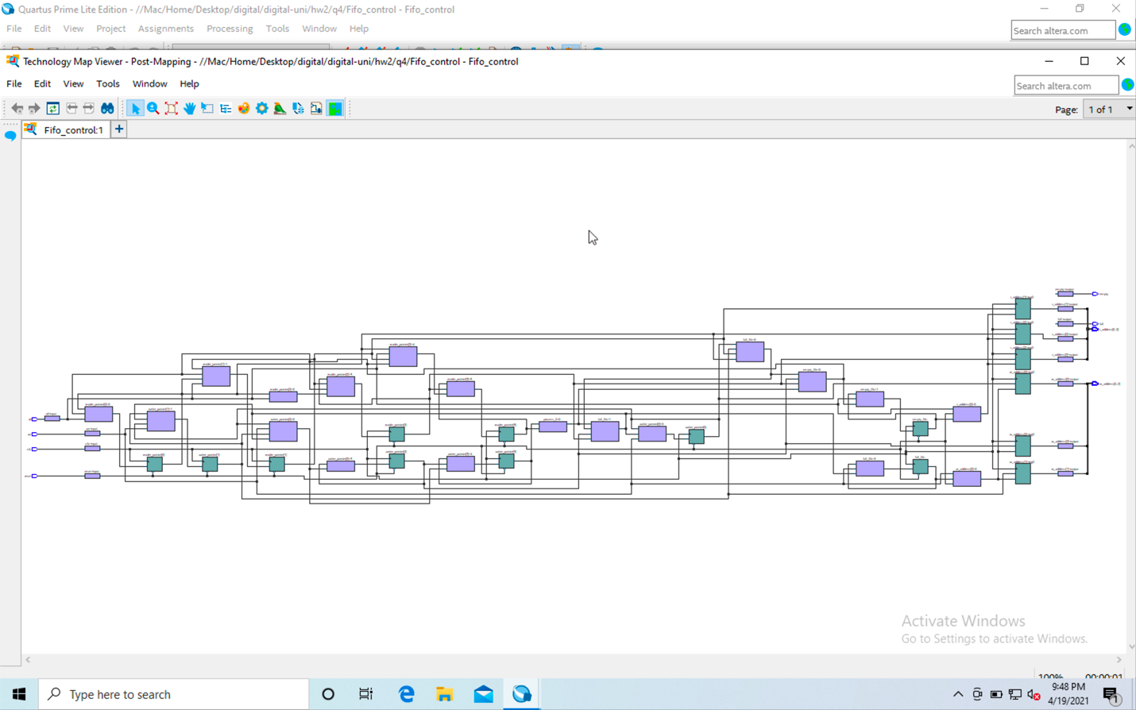

**عکس اول**

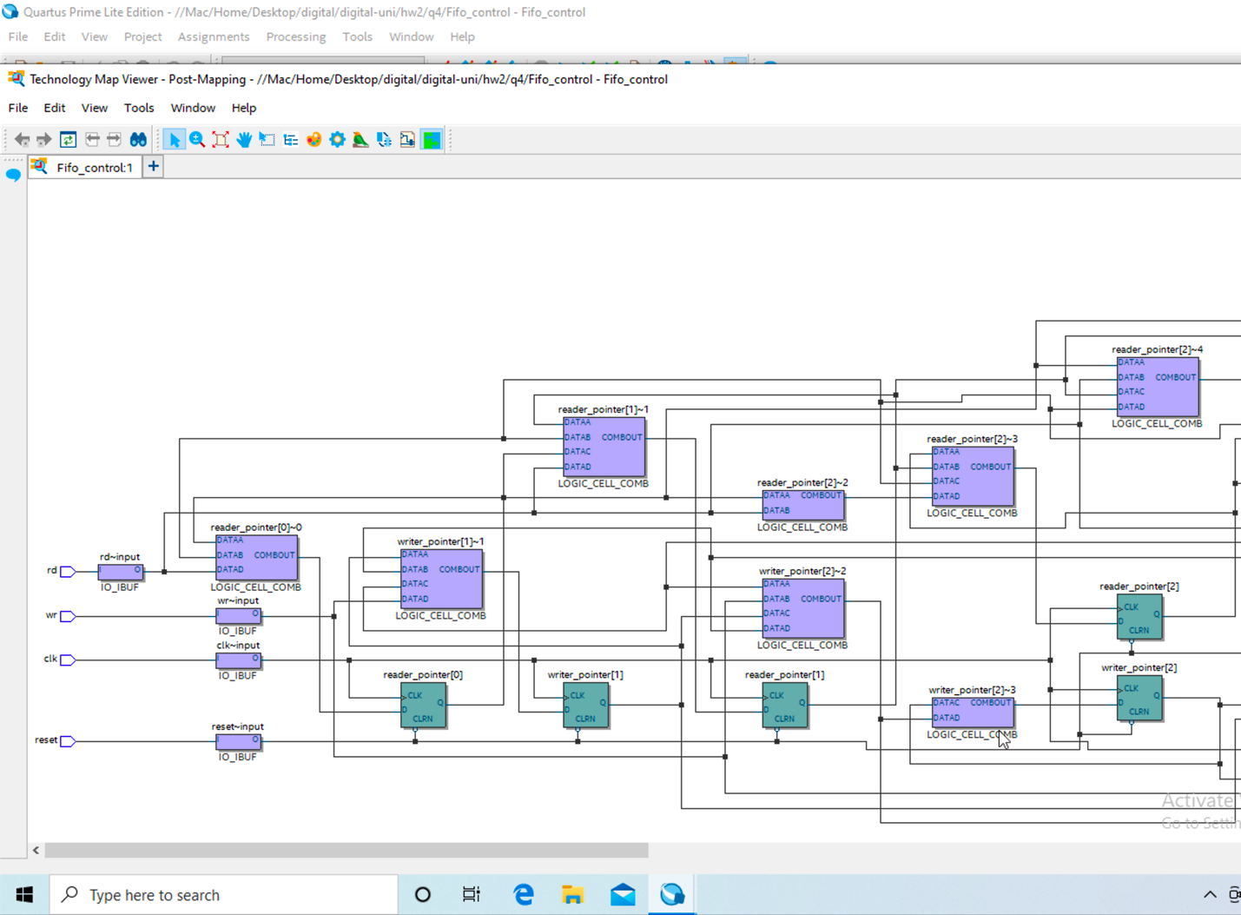

**عکس دوم**

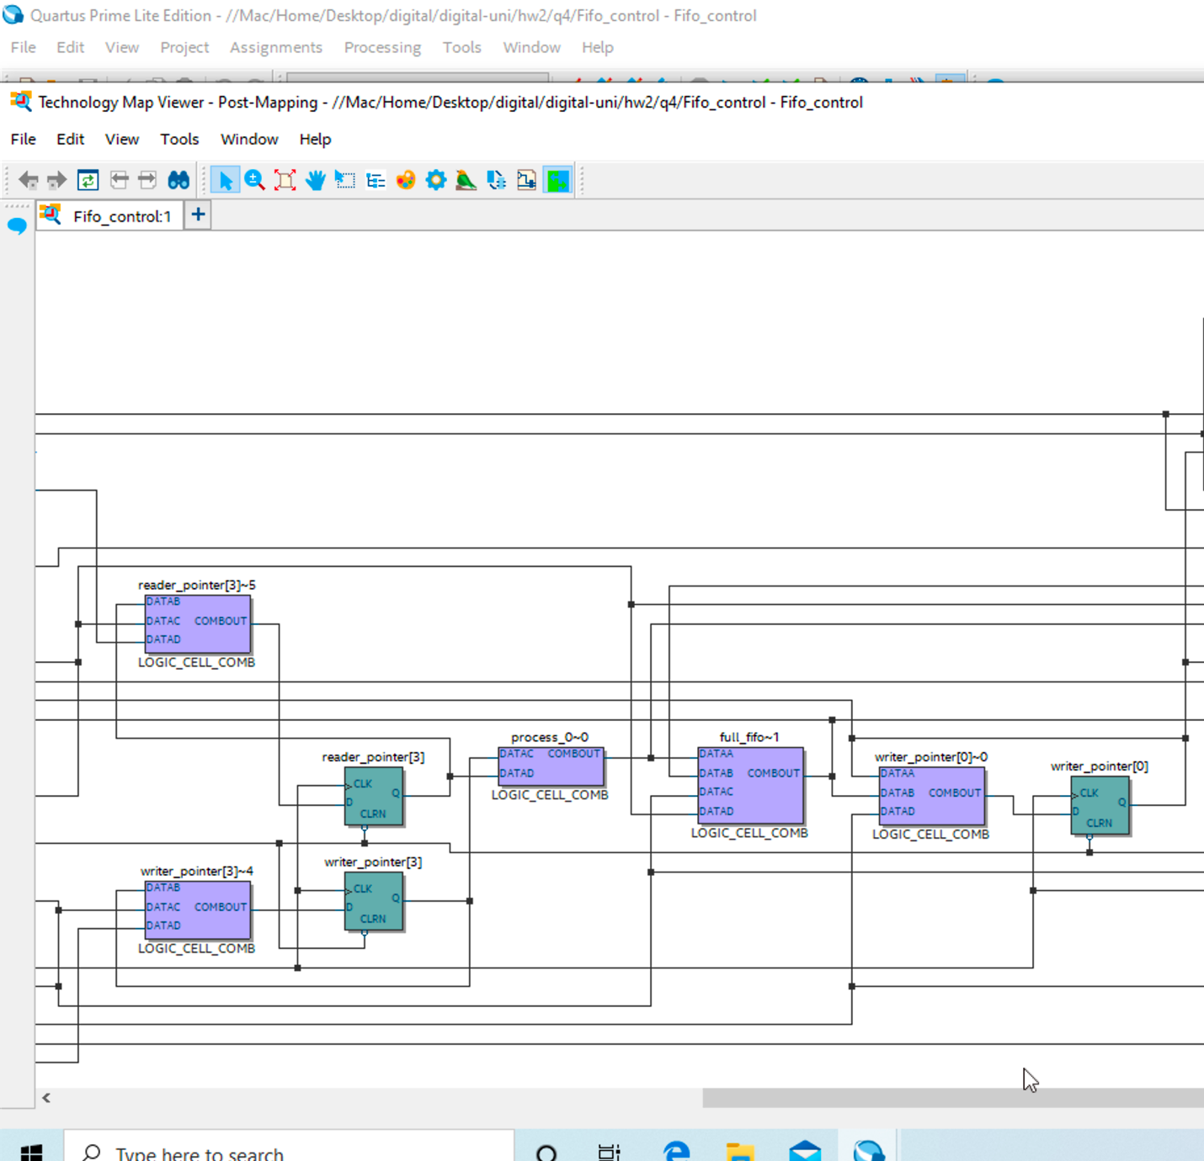

**عکس سوم**

